Eurasian National University named after L.N. Gumilyov

Faculty of «Information Technologies»

Department of «Information Systems»

**Labaratory work:** 1

**by discipline** «Development of client server IS»

**Student:** Iskakov Y.K.

**Group:** IS-35

**Checked by:** PhD. Akhmetova. A.Z.

**Laboratory work № 1. Database design**

Option №.5 DB – Travel agency..

**Purpose of the laboratory work:** To obtain theoretical knowledge and practical skills in implementing databases (DB) to “travel agency” information system. To analyze the subject area. To master conceptual design and learn to define entities and attributes of the DB. To learn to develop an infological model of the DB in the form of ER-diagrams. To obtain theoretical knowledge and practical skills in the physical design of databases (DB). To learn to create a datalogical model of the DB.

1. **Analysis of the subject area.**

A travel agency manages the organization of trips by combining clients into groups and offering a variety of tours with comfortable accommodation. Each tourist (client), contacting the agency, selects a tour depending on their preferences (for example, Kazakhstan, Almaty, by car, for a certain amount). The tourist registers in the agency’s database, where their personal data is stored, including passport data, etc. [1-2].

After selecting a tour, the tourist is included in a travel group. A travel group consists of several tourists who go on a trip along the same route and at the same time. The group is managed by a leader responsible for coordinating the trip. Information about the group, including the number of tourists, departure and arrival dates, is recorded in the agency’s system. The composition of tourist groups includes data on the date of sale of the tour, the specific travel group to which the tourist belongs, and the cost of the ticket.

Another element of the tour organization is the hotels where the tourists will stay. The travel agency cooperates with hotels of different comfort levels, giving tourists the opportunity to choose the most suitable accommodation option. The system stores information about hotels, including their location, number of beds and services provided.

All tour sales, including hotel reservations, are recorded in the sales statement. For each sale, the date, information about the tourist group, hotel and total cost are indicated. The data is used to record financial transactions and analyze the company's income.

The database plays a key role in organizing travel and allows a travel agency to effectively manage information about clients, tours, hotels and sales [3].

**Description of the main entities of SA.**

As a result of the conducted analysis of the subject area of the database "Travel agency", it is easy to list the main entities of this DB. Since at the physical level an entity corresponds to a table, we will simply list the main tables of the DB. The database for a travel agency consists of several key entities that ensure efficient management of client and service data. Tourists represent the clients of the agency. Tours are pre-planned travel routes offering various transportation, accommodation, and meal options. Tour groups include tourists grouped together for specific tours. Group composition tracks which tourists are part of which group, along with ticket sale details. Hotels provide accommodation for tourists during the trip. Sales records capture financial data related to each tour, including the total cost and associated tourist groups. These entities work together to streamline operations and enhance customer service.

Table 1. List of entities

| **№** | **Name** | **Purpose** |
| --- | --- | --- |
| 1 | Tourists | Stores personal information about tourists. |
| 2 | Tours | Contains details of tours including the destination, type of transportation, accommodation, etc. |
| 3 | Tour group | Manages information about groups of tourists. |
| 4 | Group composition | Tracks which tourists are part of which tour groups, with information. |
| 5 | Hotels | Stores information about hotels, including their characteristics. |
| 6 | Sales record | Records the financial details of sales, such as total cost, associated group, and hotel. |

For each table (entity), we will provide a description of its attributes. An attribute at the physical level is a table column and expresses a certain property of an object.

Table 2. List of table attributes «Tourists»

|  |  |  |
| --- | --- | --- |
| **Key field** | **Name** | **Purpose** |
| PK | TouristID | Unique identifier for tourist |
|  | Tourist name | The full name of the tourist. |
|  | Passport ID | Passport identification for the tourist. |
|  | Gender | The gender of the tourist (male/female). |
|  | Age | The age of the tourist. |
|  | Children | Indicates if the tourist has children. |

Table 3. List of table attributes «Tours»

| **Key field** | **Name** | **Purpose** |
| --- | --- | --- |
| PK | TourID | Unique identifier for tour. |
|  | Tour name | The name of the tour |
|  | Country | The country where the tour takes place. |
|  | Cities | List of cities included in the tour. |
|  | Type of Transport | The type of transportation (bus, plane, etc.) |
|  | Type of meal | The type of meal service provided (1x, 2x, 3x). |
|  | Tour Price | The cost of the tour per day. |
|  | Type of Accommodation | The type of lodging during the tour. |

Table 4. List of table attributes «Tour group»

| **Key field** | **Name** | **Purpose** |
| --- | --- | --- |
| PK | GroupID | Unique identifier for group. |
|  | Group Name | The name of the tourist group. |
|  | Departure Date | The starting date of the tour. |
|  | Arrival Date | The ending date of the tour. |
| FK | TourID | Reference to the associated tour. |
|  | Number of Tourists | The total number of tourists in the group. |

Table 5. List of table attributes «Group composition»

| **-/+986**  **3.0 Key field** | **Name** | **Purpose** |
| --- | --- | --- |
| PK | GroupCompositionID | Unique identifier for group composition. |
|  | Sale Date | The date of ticket sale. |
| FK | TouristID | Reference to the tourist in the group. |
| FK | GroupID | Reference to the tourist group. |
|  | Ticket Price | The price of the ticket for the tourist. |

Table 6. List of table attributes «Hotels»

| **Key field** | **Name** | **Purpose** |
| --- | --- | --- |
| PK | HotelID | Unique identifier for hotel. |
|  | Hotel Name | Name of the hotel. |
|  | Country | The country where the hotel is located. |
|  | City | The city where the hotel is located. |
|  | Address | The address of the hotel. |
|  | Number of Rooms | The capacity of the hotel (number of rooms). |
|  | Hotel Type | The category or type of the hotel (e.g., 5-star). |

Table 7. List of table attributes «Sales record»

| **Key field** | **Name** | **Purpose** |
| --- | --- | --- |
| PK | SalesRecordID | Unique identifier for Sales record |
|  | Date | The date of the sale. |
| FK | GroupID | Reference to the for tour group |
| FK | HotelID | Reference to the for hotel |
|  | Total Cost | The total cost of the sale for the group. |

1. **Construction of an infological model.**

A conceptual, or infological, model (IML) is a formalized description of a subject area, made without a strict orientation to software and technical means. A conceptual model reflects the specifics of the subject area, and not the structure of the database [4].

Types of relationship

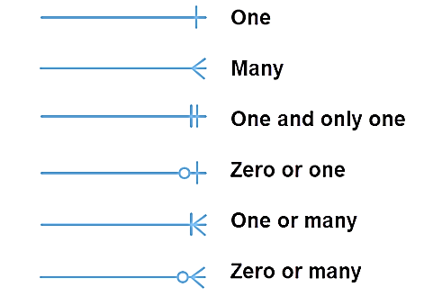

The Infological model aims to represent the real-world processes of organizing and managing tourist services by connecting these entities. Tourists are organized into groups, linked to specific tours and hotels, while sales records ensure accurate tracking of financial operations (see Figure 1.).

Figure 1. Conceptual model

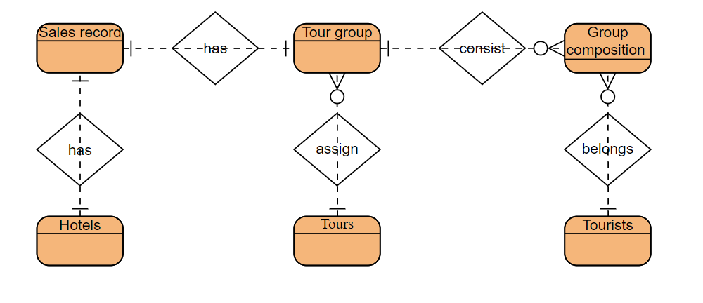

*Note:* Done by Visual Paradigm

Table 8. List of relationships

|  |  |  |  |
| --- | --- | --- | --- |
| № | Relationship Name | Entities Involved | Purpose |
| 1 | 1:N | Tourists, Group Composition | A tourist can be part of many group compositions, linking them to various tour groups. |
| 2 | 1:N | Tour Group, Tours | Many tour groups can be assigned to a single tour, defining their itinerary. |
| 3 | 1:N | Tour Group, Group Composition | A tour group consists of multiple entries in the group composition, representing tourists and their participation. |
| 4 | 1:1 | Sales Record, Tour Group | Each sales record is associated with one specific tour group. |
| 5 | 1:1 | Sales Record, Hotels | Each sales record includes one hotel where the group stays during the tour. |

1. **Construction of a datalogical model of the database.**

A datalogical model is a version of a conceptual model that can be implemented in a specific DBMS. The model displays logical relationships between data elements regardless of the storage environment. The model is built in terms of information units acceptable for the DBMS. A description of the logical structure of a DBMS in the DBMS language is called a schema [4].

Table 9. Tourist table

| **№** | **Identifier** | **Type** | **Not Null** | **Constraint** |
| --- | --- | --- | --- | --- |
| 1 | TouristID | INT | Yes | PRIMARY KEY, AUTO_INCREMENT |
| 2 | FullName | VARCHAR | Yes |  |
| 3 | PassportID | VARCHAR | Yes | UNIQUE |
| 4 | Gender | VARCHAR | Yes | CHECK (Gender IN ('M', 'F')) |
| 5 | Age | INT | Yes | CHECK (Age >= 0) or 18 etc |
| 6 | Children | BIT | No |  |

Table 10. Tours table

| **№** | **Identifier** | **Type** | **Not Null** | **Constraint** |
| --- | --- | --- | --- | --- |
| 1 | TourID | INT | Yes | PRIMARY KEY, AUTO_INCREMENT |
| 2 | Name | VARCHAR | Yes |  |
| 3 | Country | VARCHAR | Yes |  |
| 4 | Cities | VARCHAR | Yes |  |
| 5 | TypeOfTransport | VARCHAR | Yes |  |
| 6 | TypeOfMeals | VARCHAR | Yes |  |
| 7 | TourPrice | DECIMAL | Yes | CHECK (TourPrice >= 0) |
| 8 | TypeOfAccommodation | VARCHAR | Yes |  |

Table 11. Tour Group table

| **№** | **Identifier** | **Type** | **Not Null** | **Constraint** |
| --- | --- | --- | --- | --- |
| 1 | GroupID | INT | Yes | PRIMARY KEY, AUTO_INCREMENT |
| 2 | GroupName | VARCHAR | Yes |  |
| 3 | DepartureDate | DATE | Yes |  |
| 4 | ArrivalDate | DATE | Yes |  |
| 5 | TourID | INT | Yes | FOREIGN KEY (TourID) REFERENCES Tours(TourID) |
| 6 | NumberOfTourists | INT | Yes | CHECK (NumberOfTourists > 0) |

Table 12. Group Composition table

| **№** | **Identifier** | **Type** | **Not Null** | **Constraint** |
| --- | --- | --- | --- | --- |
| 1 | GroupCompositionID | INT | Yes | PRIMARY KEY, AUTO_INCREMENT |
| 2 | SaleDate | DATE | Yes |  |
| 3 | TouristID | INT | Yes | FOREIGN KEY (TouristID) REFERENCES Tourists(TouristID) |
| 4 | GroupID | INT | Yes | FOREIGN KEY (GroupID) REFERENCES TourGroup(GroupID) |
| 5 | TicketPrice | DECIMAL | Yes | CHECK (TicketPrice >= 0) |

Table 13. Hotels Table

| **№** | **Identifier** | **Type** | **Not Null** | **Constraint** |
| --- | --- | --- | --- | --- |
| 1 | HotelID | INT | Yes | PRIMARY KEY, AUTO_INCREMENT |
| 2 | HotelName | VARCHAR | Yes |  |
| 3 | Country | VARCHAR | Yes |  |
| 4 | City | VARCHAR | Yes |  |
| 5 | Address | VARCHAR | Yes |  |
| 6 | NumberOfRooms | INT | Yes | CHECK (NumberOfRooms > 0) |
| 7 | HotelType | VARCHAR | Yes |  |

Table 14. Sales Record table

| **№** | **Identifier** | **Type** | **Not Null** | **Constraint** |
| --- | --- | --- | --- | --- |
| 1 | SalesRecordID | INT | Yes | PRIMARY KEY, AUTO_INCREMENT |
| 2 | Sdate | DATE | Yes |  |
| 3 | GroupID | INT | Yes | FOREIGN KEY (GroupID) REFERENCES TourGroup(GroupID) |
| 4 | HotelID | INT | Yes | FOREIGN KEY (HotelID) REFERENCES Hotels(HotelID) |
| 5 | TotalCost | DECIMAL | Yes | CHECK (TotalCost >= 0) |

**References**

1. Chenxi, Xu. (2024). 1. The design of relational database and NoSQL database in travel agency database system. Applied and Computational Engineering, doi: 10.54254/2755-2721/43/20230822
2. Darla, S. K., & Datla, D. V. (2016). Travel agency database. ResearchGate. doi: 10.13140/RG.2.2.31846.83526.
3. Загвозкина К.А. (2017). Особенности проектирования базы данных для туристического агентства. Форум молодых ученых, (7 (11)), 244-246.
4. *Уровни моделирования предметной области*. (2017). source: https://poznayka.org/s99376t1.html